**Assignment 02**

1. Write a query that produces all rows from the Customers table for which the salesperson’s number is 1001.

**select * from customers where snum=1001;**

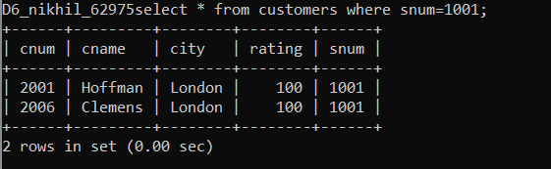

End.

2. Write a select command that produces the rating followed by the name of each customer in San Jose.

**select cname,city,rating from customers where city='san jose';**

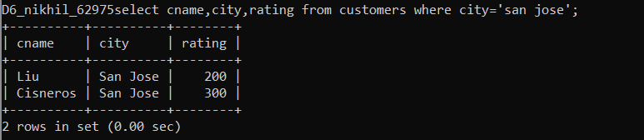

End.

3. Write a query that will produce the snum values of all salespeople from the Orders table (with the duplicate values suppressed).

**select * from salespeople order by snum;**

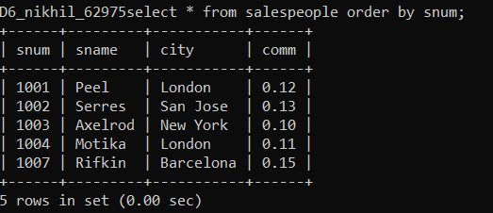

End.

4. Write a query that will give you all orders for more than Rs. 1,000.

**select * from orders where amt>1000;**

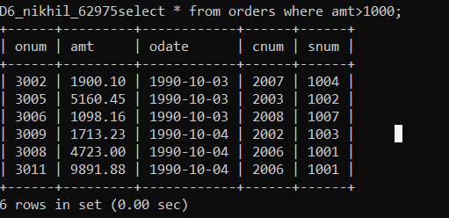

End.

5. Write a query that will give you the names and cities of all salespeople in London with a commission above 0.10.

**select * from salespeople where city='london' and comm>0.10;**

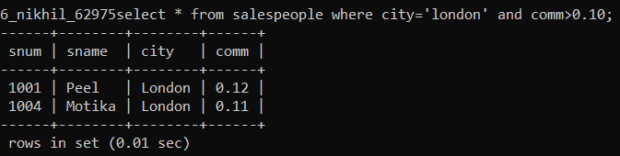

End.

6. Write a query on the Customers table whose output will exclude all customers with a rating <= 100, unless they are located in Rome.

**select * from customers where rating>100 and city!='rome';**

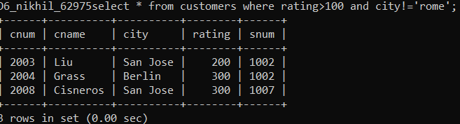

End.

7. What will be the output from the following query? Select * from Orders where (amt < 1000 OR NOT (odate = ‘1990-10-03’ AND cnum > 2003));

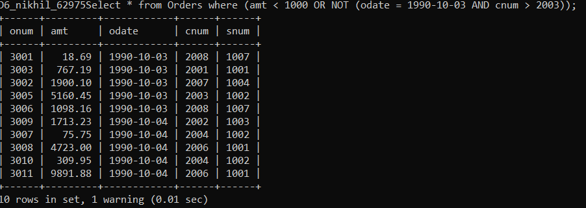

End.

8. What will be the output of the following query? Select * from Orders where NOT ((odate = ‘1990-10-03’ OR snum >1006) AND amt >= 1500);

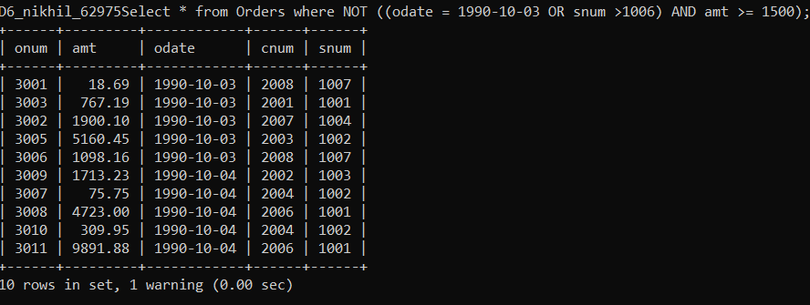

End.

9. What is a simpler way to write this query? Select snum, sname, city, comm from Salespeople Where (comm >= .12 or comm <= .14);

**select * from salespeople where comm between 0.12 and 0.14;**

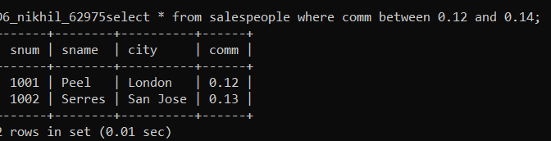

End.

10. Write a query that selects all of the customers serviced by Peel or Motika. (Hint:the snum field relates the two tables to one another).

**select * from customers where(snum=1001 or snum=1004);**

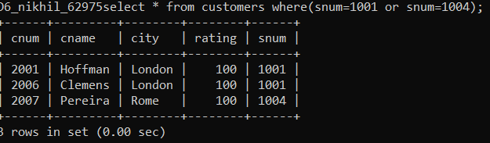

**End.**

11. Write a query that selects all orders except those with zeroes or NULLs in the amt field

**select * from orders where(amt!=0 or amt!=null);**

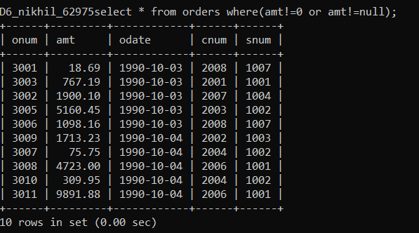

**End.**